The National Trust for Historic Preservation names Jamestown
one of America’s 11 Most Endangered Historic Places
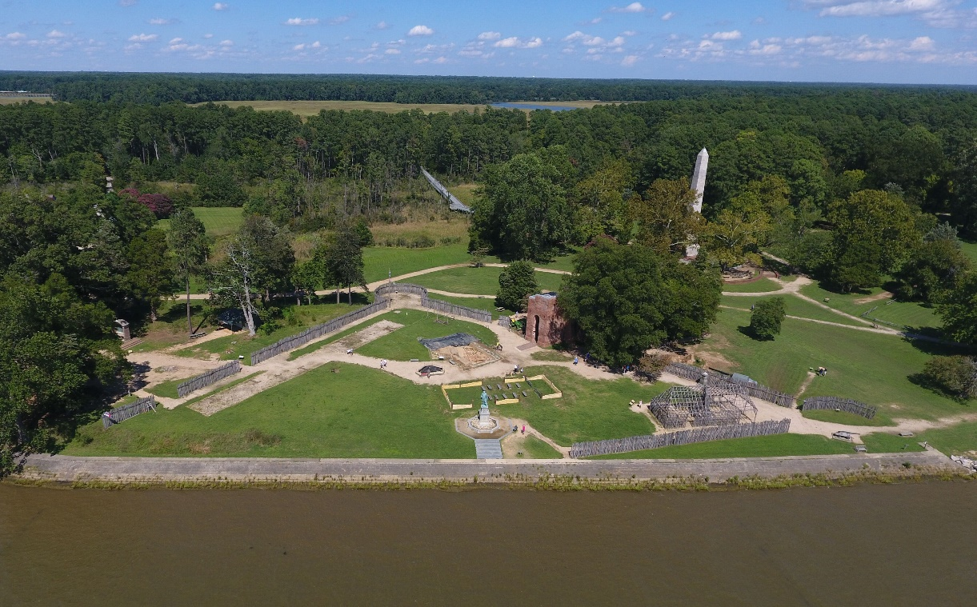
JAMESTOWN, Va. (May 4, 2022) – Recognizing the significant threats posed from the impact of climate change, the National Trust for Historic Preservation has named Jamestown to the 2022 list of America’s 11 Most Endangered Historic Places.
The first successful English settlement in North America, Jamestown developed into the first capital of Virginia and played a pivotal role in our nation’s history, providing the backdrop against which early and fateful encounters among the English colonists, native peoples, and enslaved Africans took place. When the settlers arrived in Virginia, they selected the site they would call Jamestown owing to its location along the banks of the James River. Now, the remaining archaeological record of that history is at risk of being permanently lost.
“More than 125 years ago, the far-sighted founders of Preservation Virginia took on the responsibility to protect Jamestown Island from shoreline erosion caused by the James River. They saved the Church and location of the original fort,” said Elizabeth Kostelny, CEO of Preservation Virginia, the owner of the site. “Ever since, we have protected Jamestown but now the environmental threats we face have become far more challenging.” Predictive models, following the current trajectory of climate change, reveal that within the next half-century much of Jamestown will be under water. “Each major weather event increases the likelihood of irreversible damage to Jamestown’s priceless archaeological resources,” Dave Givens, Director of Archaeology, remarked. “The next five years will be critical. If we miss this window the effort to save the site will become hugely more difficult.”
Since excavations began in 1994, Jamestown archaeologists have discovered evidence of the original fort and buildings, and over 3-million artifacts which provide new insights into the lives of indigenous peoples, enslaved Africans, and Europeans on Jamestown Island. Ongoing public excavations, expert-led tours, and award-winning exhibitions all on site provide a deeper view of our complex and shared past for hundreds of thousands of visitors from around the world. “That a place as central to our shared history as Jamestown could be lost to sea level rise and storm surges illustrates how vulnerable our historic places are in the face of climate change,” said Katherine Malone-France, Chief Preservation Officer of the National Trust. “There is true urgency to take action to mitigate climate change and adapt to its growing impacts, or many of the places that help define us as a nation may be lost forever.”
Measures have been identified that would greatly alleviate the worst effects of climate change on the site for the rest of the century, but the cost will be considerable. “That is why we are launching today a call to action to Save Jamestown,” said Jim Horn, President and CO of the Jamestown Rediscovery Foundation. “Please join us to protect this remarkable place, today and for future generations.”
If you would like to find out more, see www.historicjamestowne.org/savejamestown

ABOUT PRESERVATION VIRGINIA
Preservation Virginia is a private, nonprofit organization and statewide historic preservation leader that is dedicated to preserving, promoting and serving as an advocate for Virginia's cultural and architectural history. preservationvirginia.org

ABOUT THE JAMESTOWN REDISCOVERY FOUNDATION
The mission of the Jamestown Rediscovery Foundation is to uncover, preserve, and share Jamestown’s diverse history and its contributions to the foundations of America. historicjamestowne.org

ABOUT THE NATIONAL TRUST FOR HISTORIC PRESERVATION
The National Trust for Historic Preservation, a privately funded nonprofit organization, works to save America’s historic places. savingplaces.org

